Case 17-AM,C-Taino-Cemi Head-Serpentine-Type One-Fewkes-1000-1500
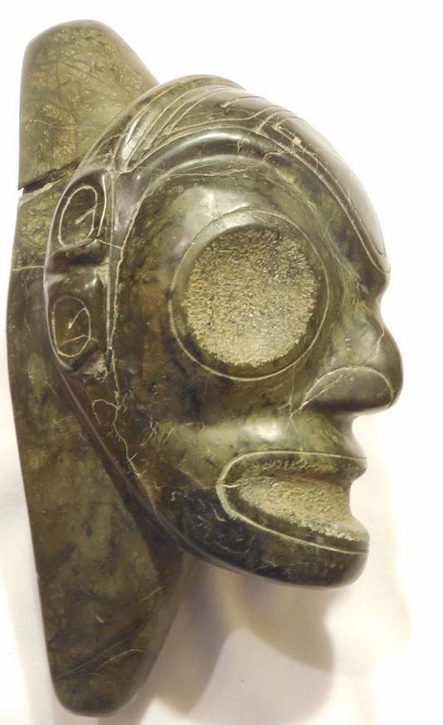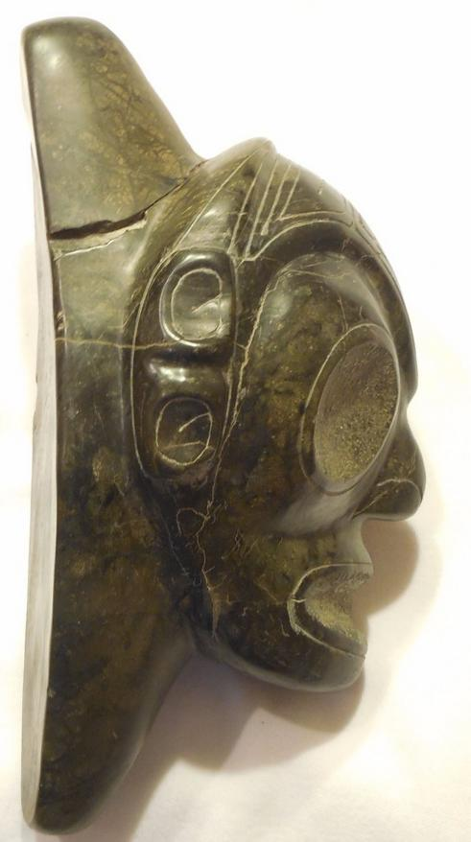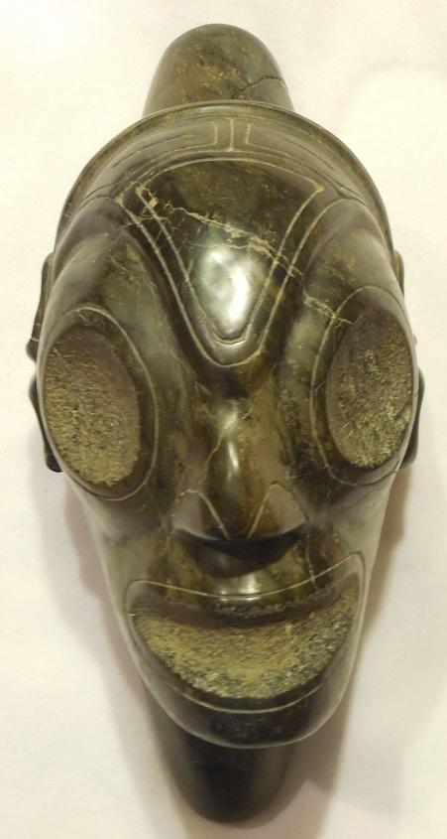

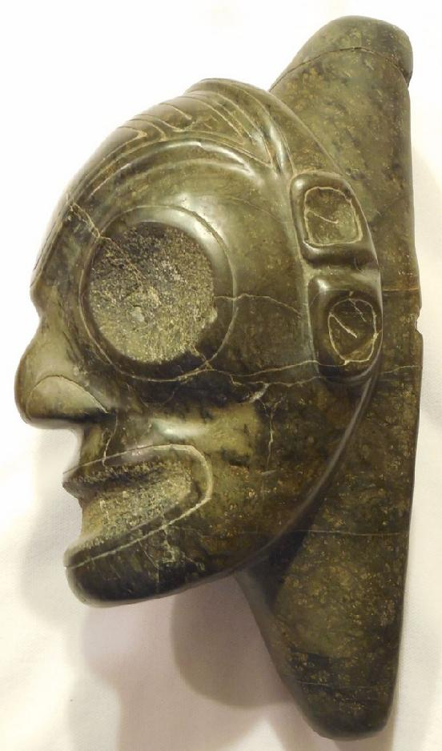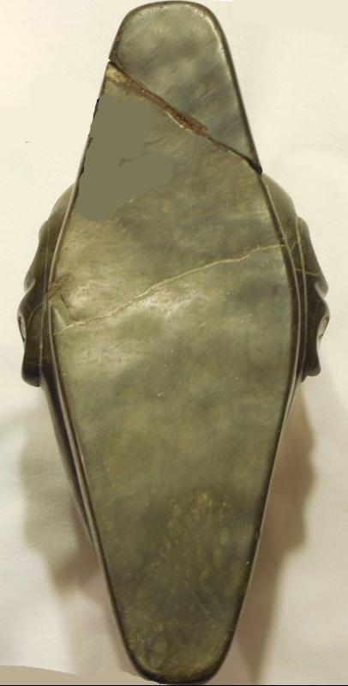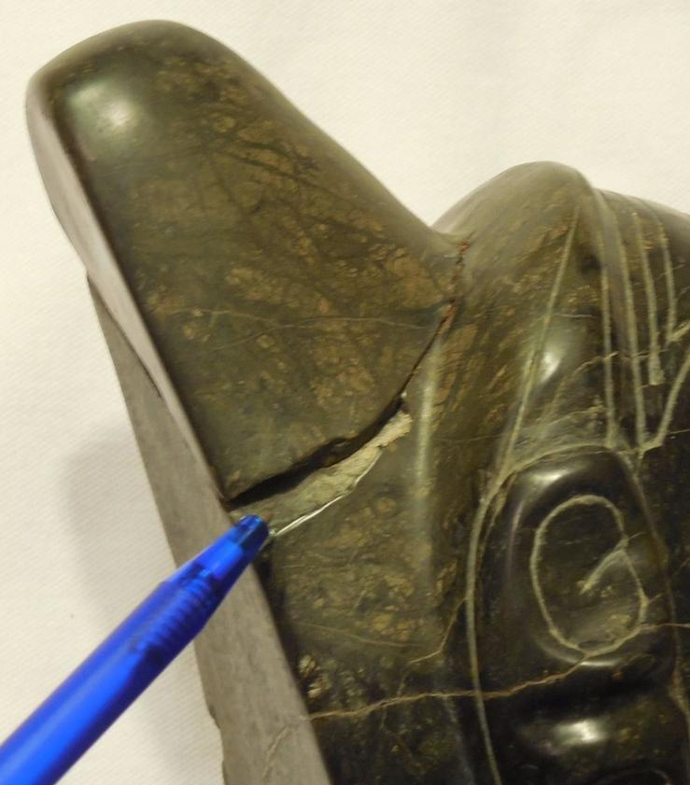

Case No.: 17
Accession Number:
Formal Label:
Display Description:
LC Classification:
Date or Time Horizon:
Geographical Area: Dominican Republic
Map:
GPS Coordinates:
Cultural Affiliation: Taino
Medium: serpentine
Dimensions: L 8' 3/4 in, H 4.25
Weight: 6 lbs
Provenance:
Condition: please note: This item has been broken in the base, and was glued back together and has some scratches.
Discussion:
References:

Order details

Sales order
Sold by jeanpier_360 ( 95 )

Delivery package 1 of 1
Estimated delivery Saturday, Jan 16, 2016
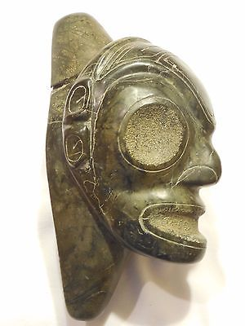

TAINO PRE-COLUMBIAN STONE HEAD
Item price | $175.00
Quantity | 1
Item number | 262221566039
Shipping service | USPS Priority Mail Medium Flat Rate Box

Shipping address

Ralph J Coffman Jr
149 Atlantic Ave
Swampscott MA 01907-2427
United States

Order total

Subtotal | $175.00
Shipping | $12.00
Total
$187.00

